ZHOU Kevin
Student ID : A0197122H
NUS - IE5101 - Applied Forecasting Methods
Professor : Chen Nan
Project 1 : US 2016 Presidential Primary Election


Table of Contents
2.1 Step 1: Simple Regression Model 2
2.1.1 model proposed 2
2.1.2 Results Analysis 3
2.1.2 model Checking and Diagnosis 3
Outliers 5
Collinearity Diagnosis 6
2.2 Full Regression Model 6
2.2.1 Full Run 6
2.2.1 Greedy search 7
Conclusion 7

2.1 Step 1: Simple Regression Model

2.1.1 model proposed
For the first simple regression, we will try to have a simple interpretable model. To ease the interpretation :
1- We will opt only for 5 variables
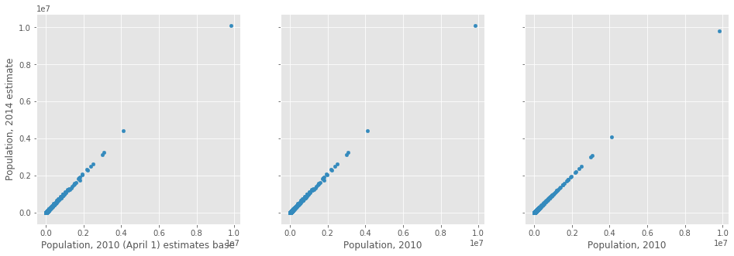
Illustration 1: Correlation between the different Population variables
2- The variable chosen should be as much non collinear as possible. We can easily suspect some level of collinearity between variables of the same category such as :
- race related variables (“White alone, percent, 2014”, “Black or African American alone, percent, 2014”, “White alone, not Hispanic or Latino, percent”, “Black-owned firms, percent, 2007”…)
- population number related variables,
- or wealthiness related variables…
This is particularly true for the population number across the years in the 3 scatter plots below where we observe a nearly perfect identity function when plotting against each other.
3- We choose the variables one by one with the maximum R squared value to have for the maximum explained variance (a simple linear regression with the variable). This is however just a simplification and would surely not yield the most accurate results.

With the below 3 criteria: our model will use the following 5 features, as they will represent respectively, age, gender, race, education level and wealthiness of the county and have a level of non collinearity mutually.
1 | Q("Persons 65 years and over, percent, 2014") | 'AGE775214'
2 | Q("Female persons, percent, 2014") | 'SEX255214'
3 | Q("Black or African American alone, percent, 2014") | 'RHI225214'
4 | Q("High school graduate or higher, percent of persons age 25+, 2009-2013") | 'EDU635213'
5 | Q("Persons below poverty level, percent, 2009-2013") | ‘PVY020213'

2.1.2 Results Analysis
The OLS regression with the 5 variables above and a intercept value gives the following results.
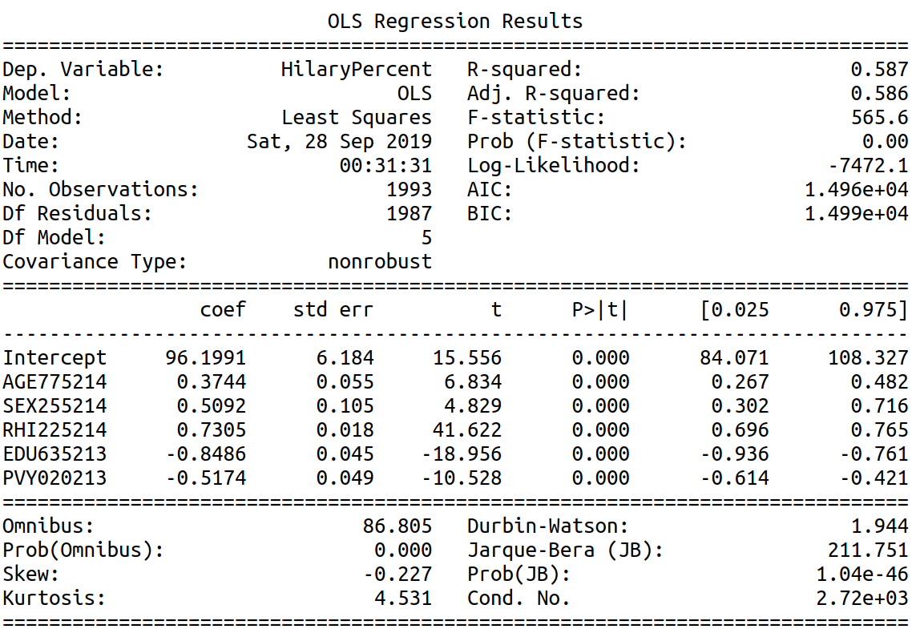
Illustration 2: OLS Regression results with training set (train-test split of 80% and 20%)
With 5 variables, the R-squared indicates that 58.7 % of the variation are explained by this model containing 5 variables.
All the variables’ p-value are close to zero and their associated t-score big meaning that they all are relevant in the model.
The big value of the F-statistic also goes along that way.

2.1.2 model Checking and Diagnosis
We will mainly check the validity of the below assumptions made by the ordinary least squared regression:
- Normality assumptions checks based on residuals
- Uncorrelated predictors assumptions
- Homoscedasticity assumption i.e. the constant variance is the predictors and the dependent variable.
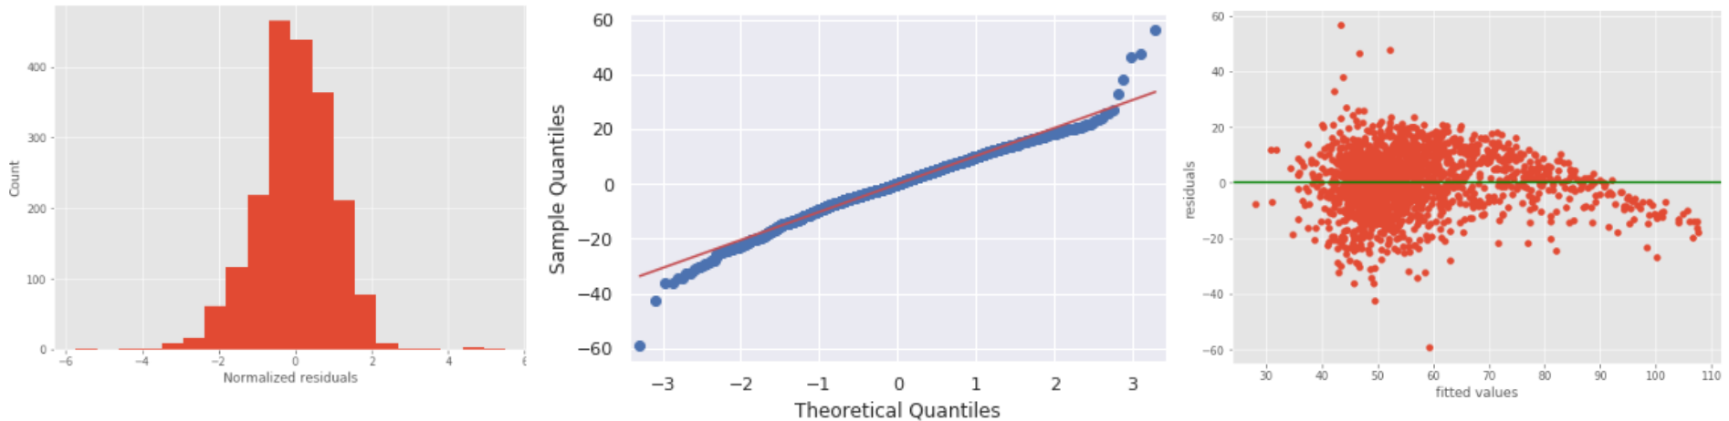
Illustration 3: (from left to right) histogram of normalized residuals, qq plot of the residuals, scatter plot of the residuals against the fitted values
The quantile-quantile plot of the residuals shows a rather close fit to the normal distribution in the middle. The histogram plot also display a pretty good normally distributed values of residuals.
However in the upper and lower tails, we notice departure from the fitted normal line making it a long-tail distribution. Either data does not satisfy normal assumption or the model is not sufficient enough to describe the dependent variable.

The scatter plot of the residuals against the fitted values shows more clearly some curving and also a slight non-constant variance in the distribution of residuals with smaller variance on higher end of fitted values. The homoscedasticity and normality assumptions seem not to be respected.

The partial plots of residuals against the 4 predictors ('AGE775214', 'SEX255214', 'EDU635213', 'PVY020213') don’t show any particular violation of assumptions.

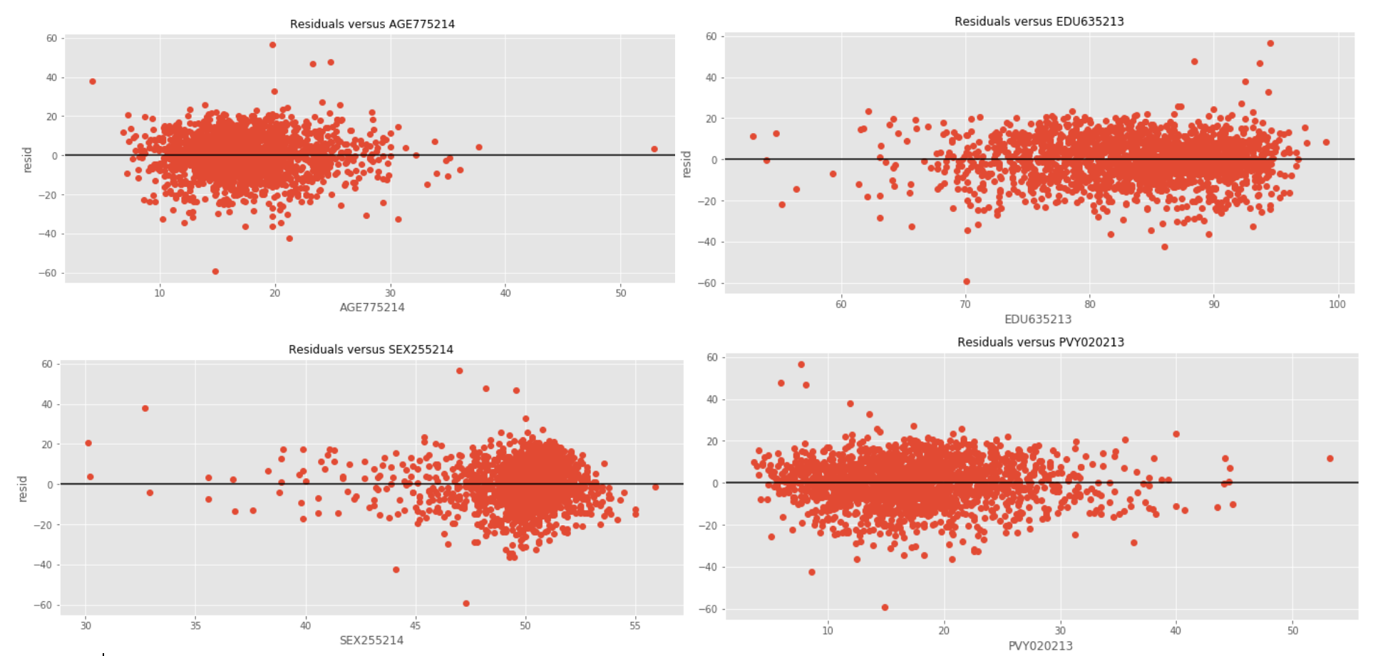
Illustration 4: Partial plots of residuals vs predictors : 'AGE775214', 'SEX255214', 'EDU635213', 'PVY020213'
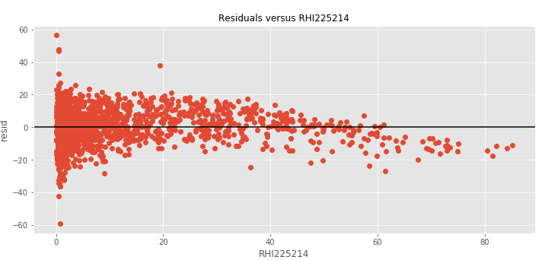
Illustration 5: Partial plots of residuals vs predictors ‘RHI225214’
The partial plot of residuals against predictor ‘RHI225214’ shows however some clear curvature.

We can apply a square root transformation to the predictor which is easier than the log transformation since the predictor variable contains values equal to 0.

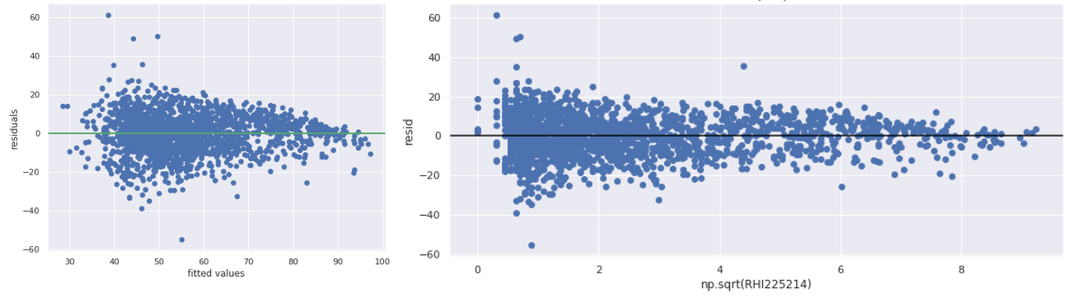
Illustration 6: the residuals plot against fitted values and against the predictor
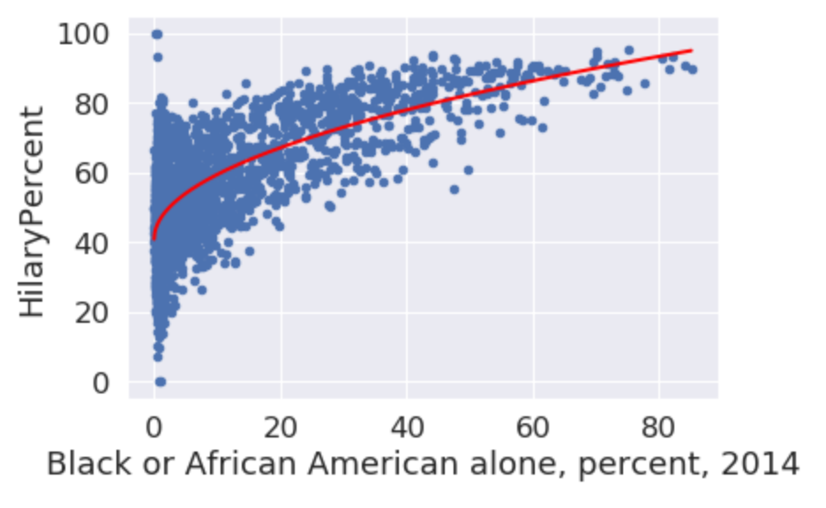
Illustration 7: Scatter plot of HilaryPercent against RHI225214
The model with the square root of RHI225214 instead of RHI225214 has indeed removed the curvature from both the residuals plot against fitted values and against the predictor. This is due to the non linearity of the predictor as shown in the scatter plot.
The variance explained has been improved to R²=60.1%. However we still observe the non constant-variance of the residuals as variance of residuals tends to decrease when the predictor increases.

Outliers
Assessing the magnitudes of the Cook's distance of the observations does not yield any particular results. Based on this There are no points with high enough values to be considered to be a possible problem (all distance are inferior to 0.1)
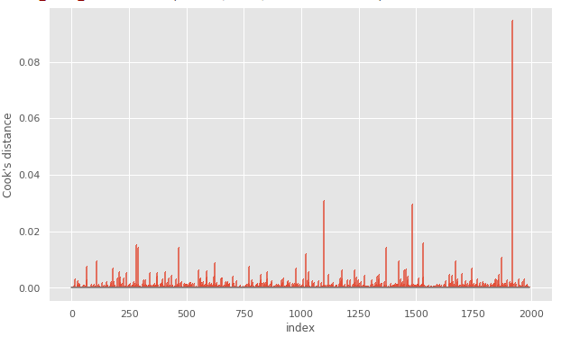
Illustration 8: Outlier identification with the Cook's distance

The influence plots gives however points that may need our attentions. There are quite a number of low leverage influential points that may distort our regression model in the blue rectangles below.
We can also distinguish some high leverage and high influential points that may cause even more issues displayed below in green rectangles.
Those points have typically low number of population. In the next model we will build, we may want to include the number of population/voters in our model.
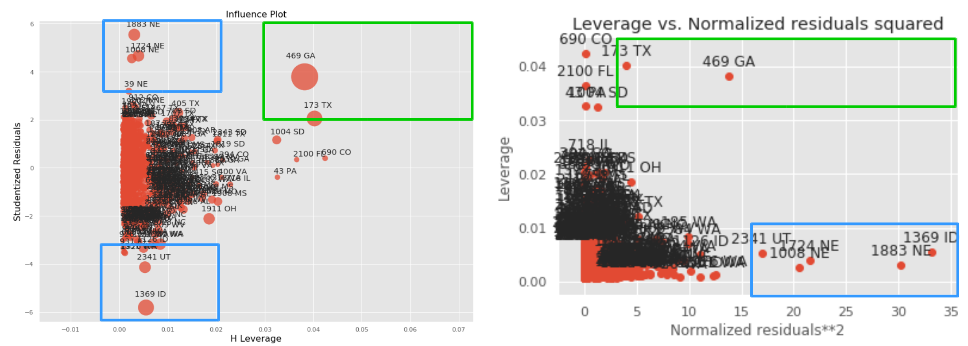
Illustration 9: Outliers identification by comparing values of leverage and residual

Collinearity Diagnosis
The collinearity level between the predictors of our model could be assessed by computing the VIF (Variance inflation factor). We can claim the multicollinearity problem is neglectable in our modal since they all have a VIF below 5.
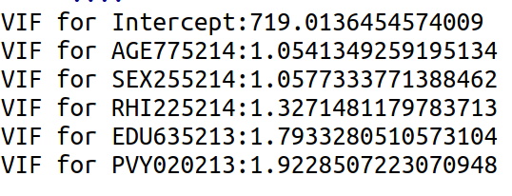

To conclude, the current modal still have a quite low R² square. Lots of variance is not explained by the variables chosen as it would be logic to think so since there is more than 40 unexploited variables.

2.2 Full Regression Model
The metrics used to evaluate the model will be the weighted mean squared errors WMSE.
To optimize our modal parameters according to this error function, we will opt for the weighted least square regression. (sm.WLS of the statsmodal library)
I implemented a cross validation as the modal validation technique for assessing the accuracy of our modal.

2.2.1 Full Run
A run of every combination of features (52 features in total) would be computationally too costly to execute. We would have to fit the linear regression n times with n == 4.5 10¹⁵ combinations.
My computer computes roughly R=10 linear regressions per seconds. It would have taken n/R=4.5 10¹⁴ seconds to perform the full run. This is only considering only untransformed combination of features and only considering the principal effects of each features.

2.2.1 Greedy search
With the packages provided in the case study in class, I firstly performed a forward and backward selection search based on the the AIC neglecting the interaction effects.
The train and test error are computed based on a 80-20 % split. Are also calculate the R square and the WSME using a 10-fold cross validation.

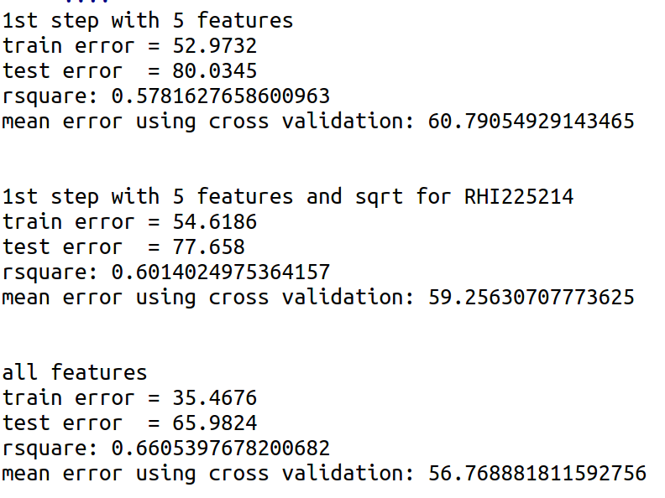
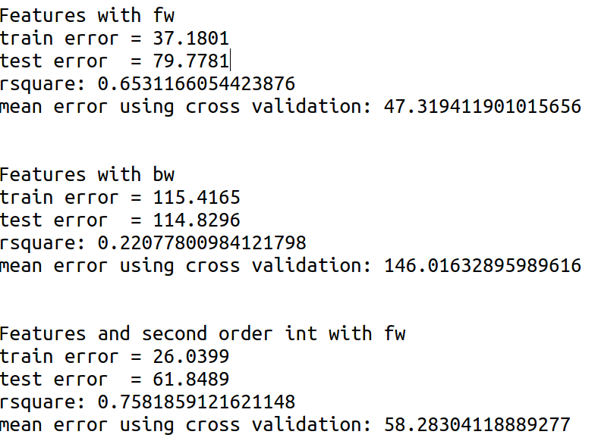
1

2

3
4

5

6

We can notice that all models trained seems to have overfitting patterns. The test errors obtained is much bigger than the training error. The best results comes out to be the modal resulted from the forward selection based on the cross validation error.
Applying a Linear regression weighted (WLS) by the number of democratic voters (Clinton voters + Sander voters) yields much better results on the modal obtained with forward selection: The mean cv error is reduced to 35%.

Conclusion
Due to time constraints, I did not have time to run the greedy search on WLS. Further works would include: running the greedy search on WLS by using different evaluation metrics and an in depth diagnosis of the modal as done in terms of outliers, collinearity, and other linear regression assumptions.

